# [Mariska Hargitay and Chris Meloni reunite for sun-soaked selfies before 'SVU' spinoff](https://www.today.com/today/amp/tdna187275?__twitter_impression=true&s=09)

See Olivia Benson and Elliot Stabler together again!

July 20, 2020, 9:03 AM EDT / Source: TODAY

By Ree Hines

They’re expected to [reunite on the small screen in the fall](https://www.today.com/popculture/christopher-meloni-predicts-benson-stabler-crossover-svu-spinoff-t186095), but “Law & Order: SVU” fans don’t have to wait for a new spinoff series or crossover episodes of the classic show to see former co-stars [Mariska Hargitay](https://www.today.com/popculture/mariska-hargitay-welcomes-chris-meloni-back-law-order-franchise-t177516) and [Christopher Meloni](https://www.today.com/popculture/christopher-meloni-bringing-back-svu-character-new-series-t177221) together again.

On Sunday night, the pair behind the beloved duo of Olivia Benson and Elliot Stabler shared a couple photos on social media that are good enough to tide over their most devoted fans.

***Watch*** [***TODAY All Day***](https://www.today.com/allday)***! Get the best news, information and inspiration from TODAY, all day long.***

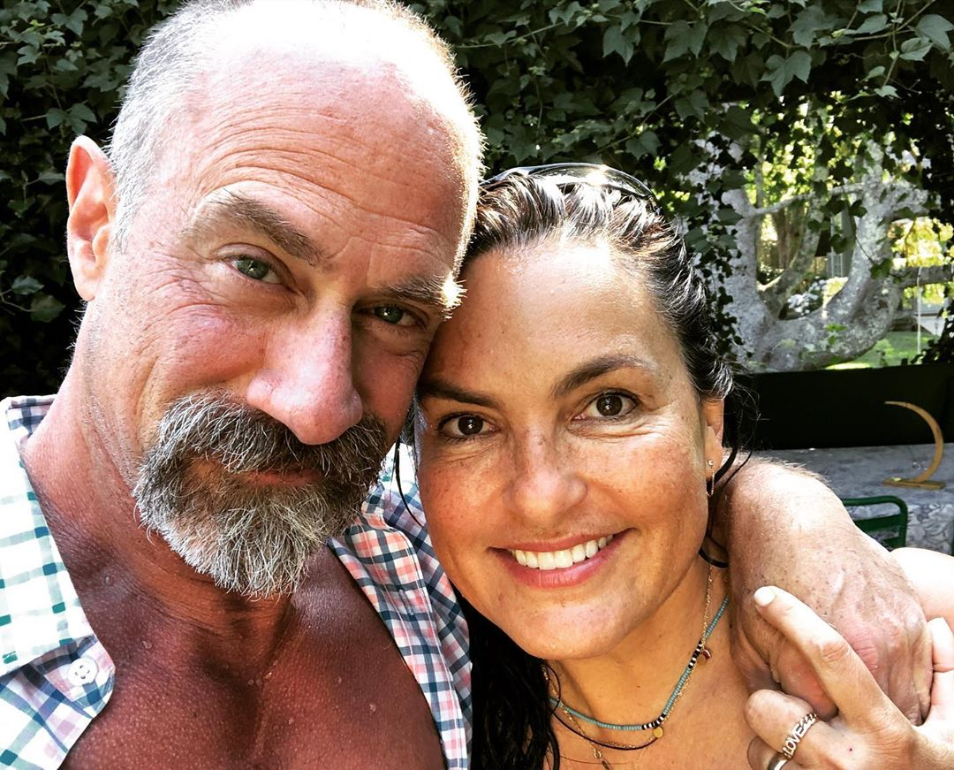

“It’s on,” wrote Hargitay alongside [a sweet shot](https://www.instagram.com/p/CC2EXmFniR6/) of her and the on-screen partner she parted ways with almost 10 years ago.

In the outdoor pic, Meloni, 59, has one arm around his old pal as they smile and lean in close. Hargitay, 56, later shared [an almost identical shot](https://www.instagram.com/p/CC2epMgnqpe/) with the caption, “Easy like Sunday mornin.”

The actor followed those up with [one of his own](https://www.instagram.com/p/CC2UcUdgAgI/) from the same casual shoot — featuring one added subject.

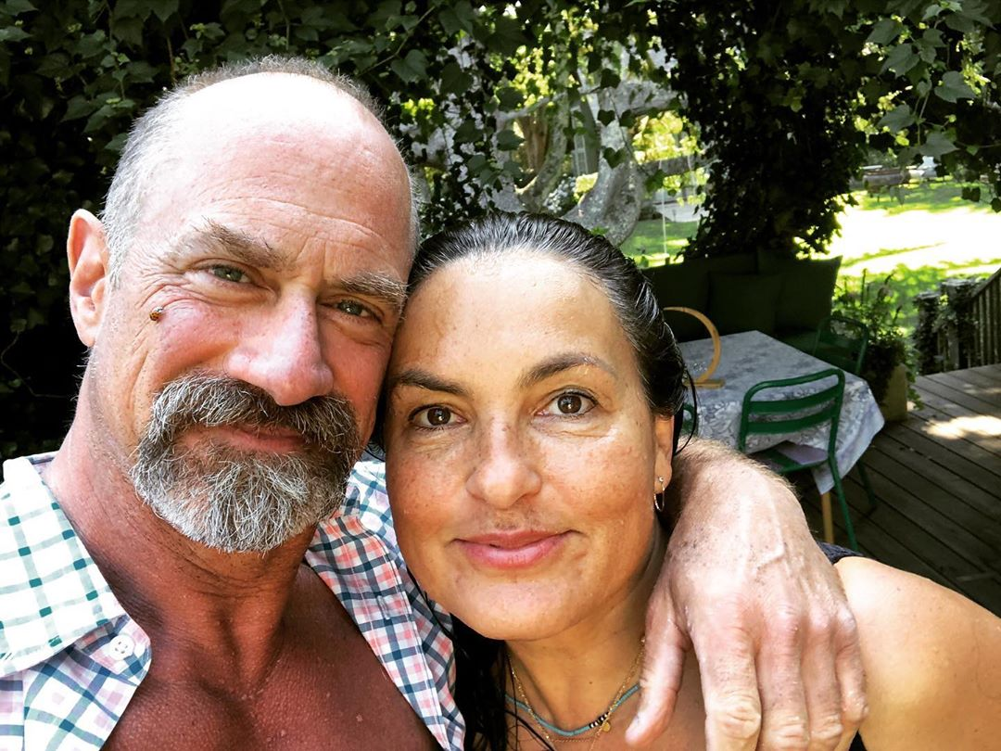

“Ladybug on my face n a lady on my arm,” he wrote of the snap.

He added the apt hashtag “#hanginWithBenson,” which is just what his character will be doing again soon.

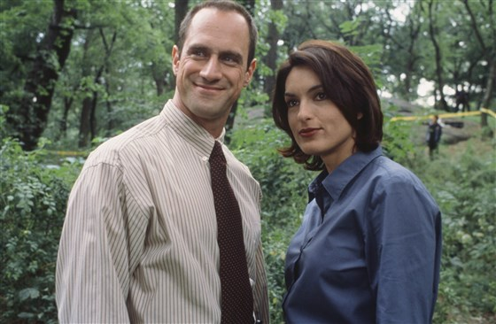Christopher Meloni stars as Detective Elliot Stabler and Mariska Hargitay stars as Detective Olivia Benson in this 1999 photo from "Law & Order: SVU." Jessica Burstein / NBC

In March, “Law & Order” viewers learned that [a new installment of the long-running franchise](https://www.today.com/popculture/christopher-meloni-bringing-back-svu-character-new-series-t177221) was on the way for the fall TV season — one that would bring back Stabler and an opportunity for him to deal with some unfinished business with his past partner.

In “Law & Order: Organized Crime,” the detective will return to the NYPD after a decade away, but first, he’s expected to swing by his old precinct.

"It’s pretty clear that Elliot will be in the 'SVU' season opener,” showrunner Warren Leight revealed during an [“SVU” behind-the-scenes podcast](https://podcasts.apple.com/us/podcast/the-law-order-svu-podcast/id1480917617?i=1000473223139) in May. “I think that much I know."

But according to Meloni, Stabler and Benson are likely to come face to face on “OC,” too.

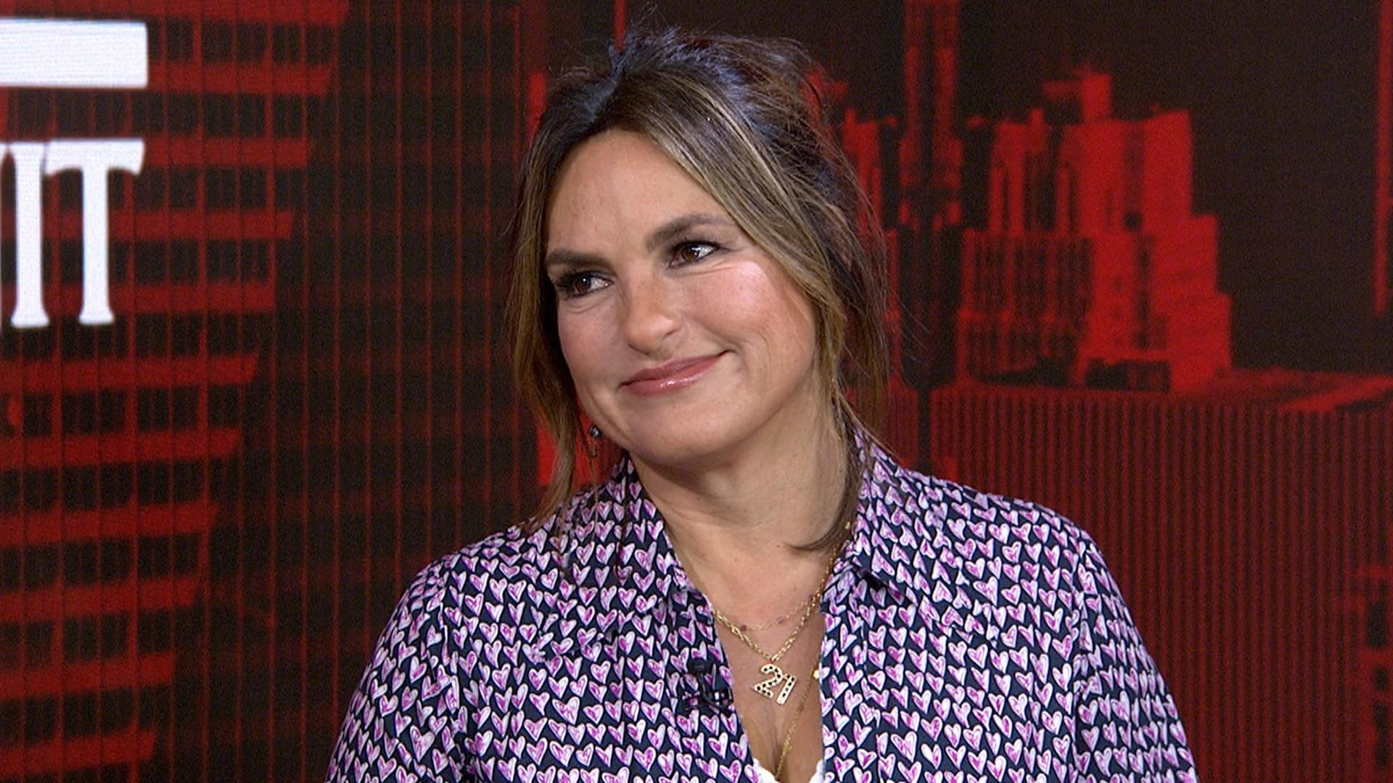

"How my character left was really unsatisfying, I think," the star [recently told the New York Post](https://www.today.com/popculture/christopher-meloni-predicts-benson-stabler-crossover-svu-spinoff-t186095). “It almost feels that (we'll) do one or two (crossover) episodes and move on our merry way."

And the more he spoke about it, the more certain he seemed.

"It just has to be," Meloni noted. "Benson and Stabler are inextricably linked, locked and connected. I think there is truly and deeply a worthwhile, inherent drama in exploring that relationship and the complexity of how Stabler left — the unresolved emotions both characters feel and how the fans feel."